January 21, 2020

Dear St. Patrick’s School Families,
Here is your Admission packet for next year. Inside you will find the necessary paperwork required to be considered for admission. I have included a checklist that needs to be completed, signed, and returned with your packet. Some important notes:
- If you are looking for financial aid, please complete the FACTS aid application at https://online.factsmgt.com/signin/3M8P0 by Feb 14th (This aid is for students in K-6 only).

- Admission packets should be completed and returned to the school office along with the $50 registration fee.

- If your application is approved, you will receive an acceptance letter for the 2020-2021 school year.

Please contact me with any questions you may have. Thank you for being a part of our school family this year and for entrusting your children to us. We look forward to providing a well-balanced education to your child(ren) next year!

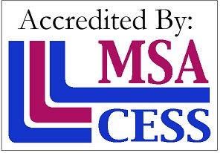
Peace and Blessings,

Mrs. K. Healt, Principal

2020-2021 ADMISSIONS CHECKLIST

I COMPLETELY FILLED OUT THE ADMISSION FORM

I ENCLOSED THE ADMISSION FEE OF $50 (PLUS $35 FOR EACH ADDITIONAL CHILD)

I FILLED OUT THE SMART TUITION FORM

I APPLIED FOR FINANCIAL AID AT https://online.factsmgt.com/signin/3M8P0
_________I do not require financial aid or am not eligible because my student is in PK

I FILLED OUT THE SCHOLARSHIP (Good News) FORM

I FILLED OUT THE TRANSPORTATION REQUEST FORM
(Canastota students: complete paper form. All others complete form online at https://www.oneidacsd.org/departments/transportation___bus_stops by April 1st)
__________I do not require transportation

____________________________________________________
Family Name

____________________________________________________ _________________________
Parent Signature Date

